Hunter Covington
English 2010
How to HEALutah

The Wasatch Front has been ranked as the worst in the nation for air pollution in the winter months. Unfortunately there is no quick fix, but businesses and individuals are taking actions to try to improve the air quality. There are many organizations out there that are trying to help fix the pollution all over the U.S. and are continuing to find new ways to. HEALutah is one of those that are doing so. They have made it possible through finding a way to use renewable energy through solar panels and by making homes that are newly built use more energy efficient standards. Help the coal plants find a way to better keep the pollution from the air and from it getting into the environment though water, and provide coal ash dumps for the mines.

Renewable energy is one of the best sources to help with pollution problems. The most common one found in Utah and that is highly encouraged from the organization HEAlutah is solar energy in the cities because do to the positioning in which the sun is able to hit solar panels at a long period of time. Generating electricity from renewable energy rather than fossil fuels offers significant public health benefits. The air and water pollution made by coal and natural gas plants is linked to breathing problems, neurological damage, heart attacks, and cancer. Replacing fossil fuels with renewable energy has been found to reduce premature mortality and lost workdays, and it reduces overall healthcare costs.

In addition HEALutah is helping with the community problems by finding ways that we can be better with our coal and mining plants. The few biggest concerns about coal plants are the amount of pollution in the air that is created from use of fossil fuels. The coal burning process is greatly damaging the earth’s environment but there are solutions to reduce the negative effects of coal. By using federal air quality regulators, it will be the best way to regulate the amount of air and water pollution and help make a cleaner environment for all of those around us. Not only are they trying to fight the pollution that is occurring during the coal plants but also the aftermath, After coal is used and burned up, they have tons of left over debris that needs to be exposed of, With the current situations in Utah there isn’t any place to store the coal, so HEALutah is trying to conduct a way that they can have a place to store the debris from the usage of coal in a safe place where it can’t contaminate water or air. Most of the after burning of coal is what causes pollution in water because it sits on the ground in a stagnant area where it can be swept away from rain or wind.
A power plant called Blue Castle which is near the Green River in Utah is trying to conduct a project that will make a nuclear power plant in Utah, However because of HEALutah they haven’t been successful in making it possible because of the many dangers with using and running a nuclear power plant. One of the biggest problems with a nuclear power plant is the radioactive waste that needs to be transported to a safe place where it can be buried miles below the surface to help get rid of any health concerns and safety. Even though it is better for the environment due to the lack of carbon dioxide factors, if not kept and run at a very precise way, can kill hundreds of thousands.
In this graph you can see the amount of pollution that starts around 2003 to 2016 and the vast change in the pollution due to many communities or organizations like HEALutah that help lower the pollution rates. (Health.utah.gov,2017)

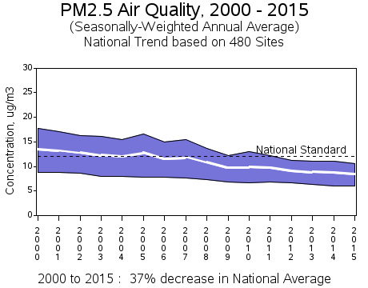

Overall HEALutah is helping our communities with things at a big portion, as people become more aware and understand what is going on in our environment they too might become more aware at some scale and understand the extreme things that are happening with pollution around us. As we find ways to be more efficient, we can handle pollution as citizens through helping understand more the way it will benefit the environment.

References:
- "Risks of Nuclear Power Plants and Radioactive Waste: Safety and Health Concerns - Video & Lesson Transcript | Study.com."Study.com | Take Online Courses. Earn College Credit. Research Schools, Degrees & Careers. Web. <http://study.com/academy/lesson/risks-of-nuclear-power-plants-and-radioactive-waste-safety-and-health-concerns.html>.

- "Clearing the air: Utah's pollution problem and what Utahns can do to improve it | Deseret News." Salt Lake City and Utah Breaking news, sports, entertainment and news headlines - Deseret News. 22 Feb 2014. Web. <http://www.deseretnews.com/article/865594625/Clearing-the-air-Utahs-pollution-problem-and-what-Utahns-can-do-to-improve-it.html>.

- Joint Fire Science Program. Dr. David Engle., Nov 2009. Web. <http://www.firescience.gov/projects/briefs/01-1-6-07_FSBrief78.pdf>.
- Web. <http://health.utah.gov/enviroepi/healthyhomes/epht/AirPollution_PublicHealth.pdf>.
- Home | Center for Science, Technology, Engineering and Mathematics (STEM) Education | UNC Charlotte. Web. <http://cstem.uncc.edu/sites/cstem.uncc.edu/files/media/SV/2010/QMRM/David%20Song-%20Coal%20Burning%20and%20its%20Effects%20on%20the%20Environment.pdf>.

- "UtahAir - Particulate Matter." Utah Department of Health | .Web. <http://www.health.utah.gov/utahair/pollutants/PM/>.

