Hunter Covington
English 2010
Environmental Health

Since man set foot on earth or however they were brought to here, one of the first things to our survival was the usage of fire. Since then we have continued to burn things to keep us warm or for power or purification. Which is an amazing benefit that we need to survive. But what if I were to sit that as we use more chemicals and natural materials in our climate, we then begin to make things die and we begin to pollute the air causing damage to all those things around us including ourselves. Through a substance called air pollution. Now what is air pollution? It is the chemicals that we burn making different forms of the materials that are used for energy that put off dangerous gasses that could kill something or someone.
There are many ways that we ourselves have polluted this country and earth, and there are many different ways that we could help change the way that it is working through renewable energy and clean energy like solar, air or wind, water, steam, mechanical or electrical, instead of burning natural resources and putting them back into the air. Coal-fired power plants are the world's biggest source of sulfur-dioxide air pollution, which contributes to smog, acid rain, and health problems that include lung disease. ... Nitrogen oxide pollution comes from vehicle engines and power plants, and plays an important role in the formation of acid rain, ozone and smog. Woodford, Chris. (2010/2017) Air pollution. Retrieved from http://www.explainthatstuff.com/air-pollution-introduction.html.
Have you ever wondered how dangerous pollution is? For small exposure it can cause irritation of the eyes, nose, and throat, wheezing, coughing, chest tightness, breathing difficulties, worsening of existing lung and heart problems such as asthma an a increase in heart attacks. These are some of the less severe things that can happen, with more long-term effects there are problems with causation of cancer, damage to the immune, neurological, reproductive, and respiratory systems and even cause death.
Not only is it dangerous for us but also it harms our environment in so many ways. 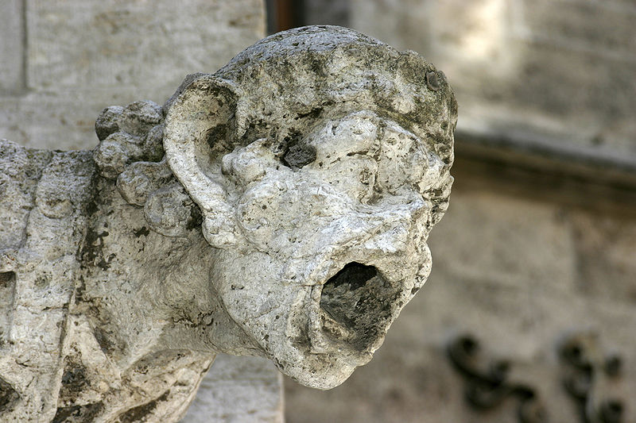

Acid rain damaged gargoyle
Our first problem is Acid rain, which is pollution that gets into the air that contains nitric and sulfuric acids. These acids are formed primarily by nitrogen oxides and sulfur oxides released into the atmosphere when fossil fuels are burned. These acids fall to the Earth either as wet precipitation.
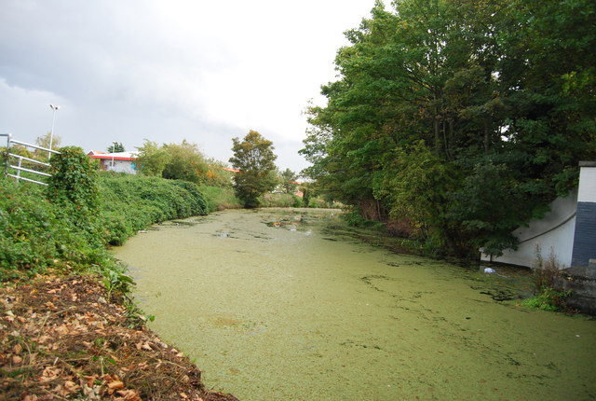

An Algal River Gipping

Our second problem is Eutrophication is a condition in a water body where high concentrations of nutrients (such as nitrogen) stimulate blooms of algae, which in turn can cause fish kills and loss of plant and animal diversity. Haze is caused when sunlight encounters tiny pollution particles in the air. Haze obscures the clarity, color, texture, and form of what we see. Some haze-causing pollutants. Effects on wildlife.
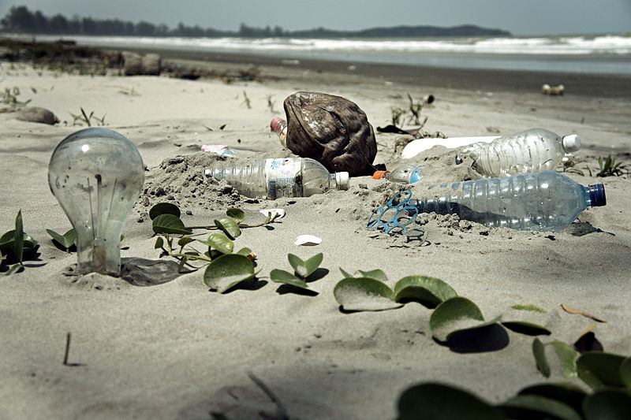

Water Pollution with Trash Disposal of Waste at the Garbage Beach

Toxic pollutants in the air, or deposited on soils or surface waters, can impact wildlife in a number of ways. Like humans, animals can experience health problems if they are exposed to sufficient concentrations of air toxics over time. Studies show that air toxics are contributing to birth defects, reproductive failure, and disease in animals.

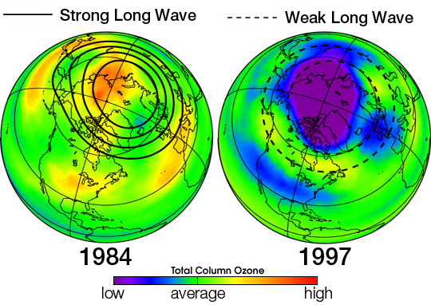

Uars ozone waves

. Ozone depletion. Ozone is a gas that occurs both at ground level and in the Earth's upper atmosphere, known as the stratosphere. At ground level, ozone is a pollutant that can harm human health. In the stratosphere, however, ozone forms a layer that protects life on earth from the sun's harmful ultraviolet (UV) rays. But this "good" ozone is gradually being destroyed by man-made chemicals referred to as ozone-depleting substances, including chlorofluorocarbons, hydrochlorofluorocarbons, and halons..
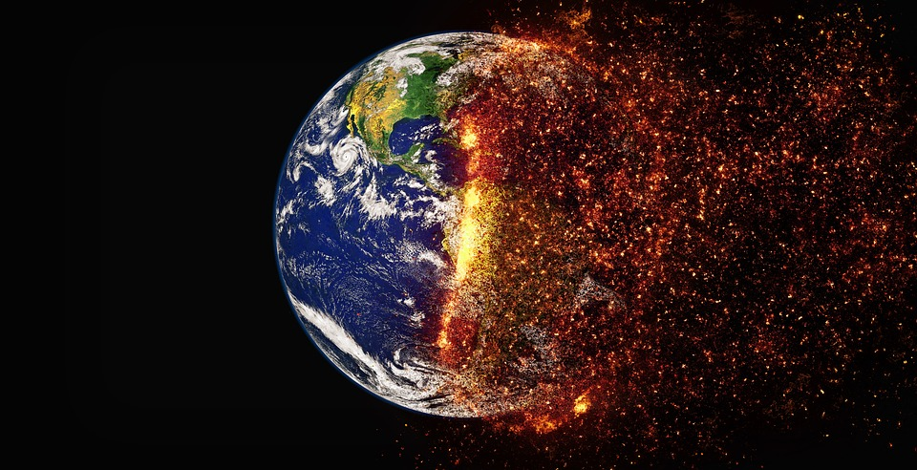

Global climate change. The Earth's atmosphere contains a delicate balance of naturally occurring gases that trap some of the sun's heat near the Earth's surface. This "greenhouse effect" keeps the Earth's temperature stable. Unfortunately, evidence is mounting that humans have disturbed this natural balance by producing large amounts of some of these greenhouse gases, including carbon dioxide and methane. Mass.gov. Web. <http://www.mass.gov/eea/docs/dep/air/aq/health-and-env-effects-air-pollutions.pdf>. these are some of the many few things that air pollution can cause.
These are some of the things that can be caused from pollution, one instance has happened in Utah where a man in Kennicott copper mine was killed do to exposure to air pollution of sulfur dioxide. The exposure was while working on a boiler when he got exposed to toxic gas. The people who work there unsure of how he was exposed only that every once in a while the boilers need to be cleaned. They are unknown as to if he was wearing a respirator while working on the job. "Kennecott worker dies after weekend exposure to sulfur dioxide. | KSL.com." Utah News, Sports, Weather and Classifieds | KSL.com. Web. <http://www.ksl.com/?sid=46123698&nid=148&title=kennecott-worker-dies-after-weekend-exposure-to-sulfur-dioxide>.
Now this is only one case of a death from exposure to high chemicals in the air, obviously a big extreme but researches from the University of British Columbia, states that air pollution is the fourth leading cause of death globally,leading to 5.5 million premature deaths worldwide each year. "We can very credibly estimate that somewhere between 1,000 and 2,000 Utahns die prematurely every year due to the air pollution," said Dr. Brian Moench with Utah Physicians for a Healthy Environment. "Doctor says Utah's air pollution leading to premature death of thousands | KUTV." Salt Lake City News, Weather, Sports, Breaking News | KUTV. Web. <http://kutv.com/news/local/doctor-says-utahs-air-pollution-leading-to-premature-death-of-thousands>.
So how can we prevent it? Every time we drive to school, use our heater or air conditioner, clean our windows, or even style our hair, we make choices that affect air pollution. These steps, as well as many others, are things we all can do to help reduce air pollution.
- Conserve energy – remember to turn off lights, computers, and electric appliances when not in use.
- Use energy efficient light bulbs and appliances.
- Participate in your local utility’s energy conservation programs.
- Limit driving by carpooling, using public transportation, biking and walking.
- Combine errands for fewer trips.
- Keep your automobile well tuned and maintained. Follow the manufacturer’s instructions on routine maintenance, such as changing the oil and filters, and checking tire pressure and wheel alignment.
- Avoid excessive idling of your automobile.
- Use electric or hand-powered lawn care equipment.
- Be careful not to spill gasoline when filling up your car or gasoline powered lawn and garden equipment.
- Run dishwashers and clothes washers only when full.
- Choose environmentally friendly cleaners.
"What Can I Do to Help Reduce Air Pollution? - Air Quality Monitoring and Data Program - NH Department of Environmental Services." Welcome | NH Department of Environmental Services. Web. <http://www.des.nh.gov/organization/divisions/air/tsb/ams/aqmdp/share.htm>.
Overall pollution is a part of our everyday lives and is affecting us at a more concentrated rate, because of industries and things that we use in our every day lives through transportation, energy, heat, etc. there are so many things that people are unaware of the we use and don’t know the damage that they are doing to themselves. Not only that but the way it changes our environment that makes it uninhabitable. Without change of the way we live. There isn’t much room to make the earth’s life shorter, and a place for us to live as well.

